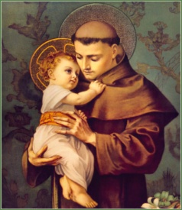
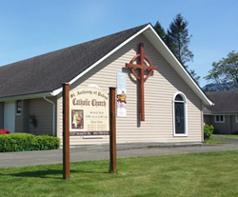
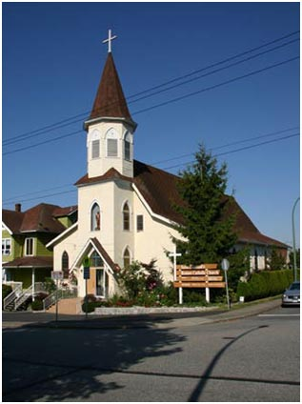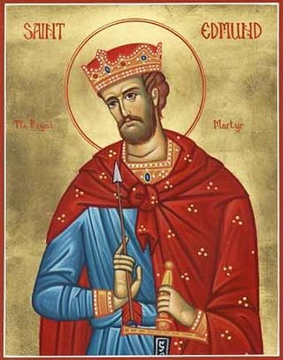
St. Edmund’s Parish
545 Mahon Ave.
Vancouver, BC V7M 2R7 Canada
Phone: (604) 988 3211 Fax: (604) 988 3261
Email: parish.sed@rcav.org or st.edmunds@shaw.ca
Web: http://www.stedmundsparish.ca/

Parent/Guardian Consent Form

I ___________________________________________give consent for my child/children
name(s) _________________________________________________________________
to join St. Edmund’s Altar Servers and Children’s Choir Picnic to the Waterpark in Aldergrove Langley, & Little Flower Monastery at Carmel Hill on WEDNESDAY, AUGUST 19TH, 2026. Please arrive at parish at 7:45am.
I understand that they will be accompanied & supervised by Father Steny, Fr Jeevan and 10 adults and will travel by bus.

Please list special instructions or allergy alerts. Thank you.
____________________________________________________________________
____________________________________________________________________

Signed: ___________________________________
Date: _____________________________________
Emergency contact number: ____________________

Note: Please return to Father Steny or the Parish Office no later than August 24, 2026

Thank you!

